Requirements Analysis
Technology Stack
Date | 10 Feb 2026
Team ID | LTVIP2026TMIDS65745
Project Name | Translingua: ai-powered multi-language translator
Maximum Marks | 2 Marks
Technical Architecture:
The Deliverable shall include the architectural diagram as below and the information as per the table1 & table 2

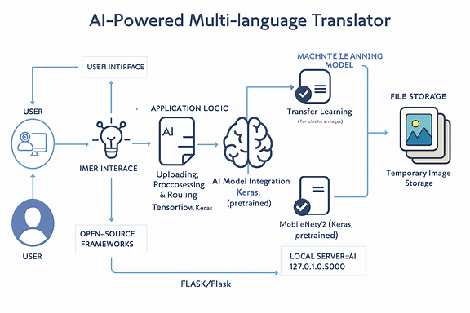

Table-1: Components & Technologies:

S.No | Component | Description | Technology
1 | User Interface | How users interact (text input, language selection, translation output) | HTML, CSS, Bootstrap 5
2 | Application Logic-1 | Handling user input, routing requests, and responses | Python, Flask
3 | Application Logic-2 | Language detection and translation inference | TensorFlow, Keras
4 | Application Logic-3 | Text preprocessing, tokenization, encoding & decoding | NLP Libraries, NumPy
5 | Database | Stores translation history and user preferences | SQLite
6 | Cloud Database | Optional cloud-based storage for scalability | Firebase / MongoDB Atlas
7 | File Storage | Temporary storage for logs and translation cache | Local Filesystem
8 | External API-1 | Language detection service (optional hybrid approach) | Google Language Detect API
9 | External API-2 | Translation API (fallback or enhancement) | Google Translate API
10 | Machine Learning Model | Neural Machine Translation for multi-language text | Transformer Model (Keras / TensorFlow)
11 | Infrastructure | Runs on local system or cloud server | Localhost Flask / Cloud VM

Table-2: Application Characteristics:

S.No | Characteristic | Description | Technology Used
1 | Open-Source Frameworks | Entire system built using open-source tools | Flask, TensorFlow, NumPy, Bootstrap
2 | Security Implementations | Input validation, secure APIs, data privacy | Flask Security, HTTPS
3 | Scalable Architecture | Modular architecture enabling easy language expansion | Flask MVC Architecture
4 | Availability | Can be deployed on cloud for 24/7 access | AWS, Heroku, Docker-ready design
5 | Performance | Real-time translation with low latency | Optimized Transformer Models

